MODEL ENGINEERING COLLEGE, THRIKKAKARA

DEPARTMENT OF COMPUTER ENGINEERING



RECORD OF PRACTICAL WORKS

OOP CST205

CLASS: CS 3 B (2019 Ad.)

Name of Student: ADITHYA A

Roll No: 03

EXP No.: 01

Hello World

AIM

Display a message in console using Java.

PROGRAM

// First program

/\*

This is a simple Java program.

Call this file "Example.java".

\*/

class Main {

// Your program begins with a call to main().

public static void main(String args[ ]) {

System.out.println("This is a simple Java program.");

}

}

OUTPUT

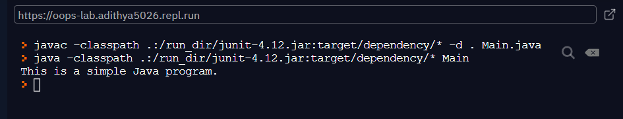

EXP No.: 02

VARIABLE DECLARATION

AIM

Demonstrate a Java program that uses variable declaration.

PROGRAM

/\*

Here is another short example.

Call this file "Example2.java".

\*/

class Main {

public static void main(String args []) {

int num; // this declares a variable called num

num = 100; // this assigns num the value 100

System.out.println("This is num: " + num);

num = num \* 2;

System.out.print("The value of num \* 2 is ");

System.out.println(num);

}

}

OUTPUT

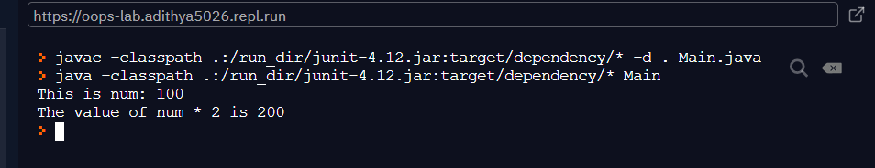

EXP No.: 03

IF STATEMENT

AIM

Program to Illustrate the use of ‘if’ in Java

PROGRAM

/\*

Demonstrate the if.

Call this file "IfSample.java".

\*/

class Main {

public static void main(String args[]) {

int x, y;

x = 10;

y = 20;

if(x < y) System.out.println("x is less than y");

x = x \* 2;

if(x == y) System.out.println("x now equal to y");

x = x \* 2;

if(x > y) System.out.println("x now greater than y");

// this won't display anything

if(x == y) System.out.println("you won't see this");

}

}

OUTPUT

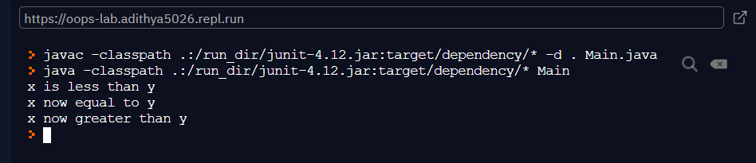

EXP No.: 04

FOR LOOP IN JAVA

AIM

Program to Demonstrate ‘for’ loop in Java

PROGRAM

/\*

Demonstrate the for loop.

Call this file "ForTest.java".

\*/

class Main {

public static void main(String args[ ]) {

int x;

for(x = 0; x<10; x=x+1)

System.out.println("This is x: " + x);

}

}

OUTPUT

